Multiple-choice section – choose the correct answer

Question 1 [6.1]

The height and capacity of five cooking containers are shown on this graph.

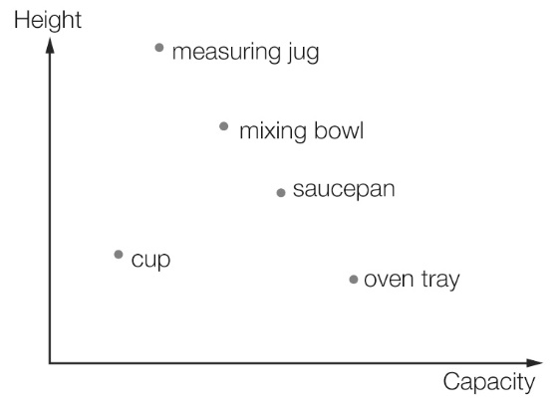

The tallest container is the:

A measuring jug B mixing bowl C saucepan D cup

Question 2 [6.1]

The graph shows the travelling pattern of a family on a day’s journey. The family started to travel home at the beginning of:

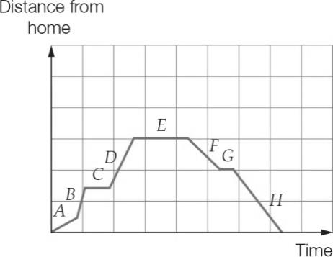

A Section *C* B Section *E* C Section *F* D Section *G*

Question 3 [6.2]

Which equation represents a straight line?

A *xy* = 3 B  C  D 

Question 4 [6.2]

An ordered pair representing a point that lies on the *x*-axis is:

A (-3, -3) B (0, 7) C (2, 0) D (1, 1)

Question 5 [6.2]

The table which matches the graph is:

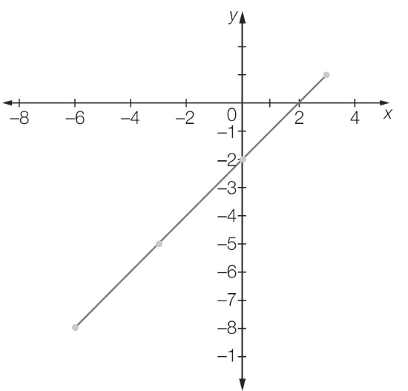

A

|  |  |  |  |  |
| --- | --- | --- | --- | --- |
| *x* | -8 | -5 | -2 | 1 |
| *y* | -6 | -3 | 0 | 3 |

B

|  |  |  |  |  |
| --- | --- | --- | --- | --- |
| *x* | -6 | -3 | 0 | 3 |
| *y* | -8 | -5 | -2 | 1 |

C

|  |  |  |  |  |
| --- | --- | --- | --- | --- |
| *x* | -1 | -2 | 5 | 8 |
| *y* | -3 | 0 | 3 | 6 |

D

|  |  |  |  |  |
| --- | --- | --- | --- | --- |
| *x* | -3 | 0 | 3 | 6 |
| *y* | -1 | -2 | 5 | 8 |

Question 6 [6.2]

Which point lies on the graph *y* = 2?

A (1, 0) B (−3, 0) C (1, −3) D (−3, 2)

Question 7 [6.2]

The coordinates of a point that lies on the graph of  are:

A (1, 2) B (2, 3) C (3, 7) D (4, 7)

Question 8 [6.3]

A rule for the set of points (2, 4), (3, 5), (4, 6) is:

A *y* = *x* B *y* = 2*x* C *y* = *x* + 2 D *x* = 2*y*

Question 9 [6.2]

The *y*-intercept of the line with equationis:

A (0, 1) B (0, 3) C (0, -1) D (0, -3)

Question 10 [6.2]

Which line has a gradient equal to zero?

A *x* = 5 B *x* = *y* C  *x* + *y* = 1 D *y* = 1

Question 11 [6.2]

What is the gradient of the line given by the equation?

A zero (flat) B nearly flat C very steep D not very steep

Question 12 [6.4]

An electrician charges a fixed fee of $100 to go to a job plus $20 per hour of work. If *C* represents the total cost in dollars and *t* represents the time the electrician works in hours, the following table of values and graph can be constructed.

|  |  |  |  |  |  |
| --- | --- | --- | --- | --- | --- |
| *t* | 0 | 2 | 4 | 6 | 8 |
| *C* | 100 | 140 | 180 | 220 | 260 |

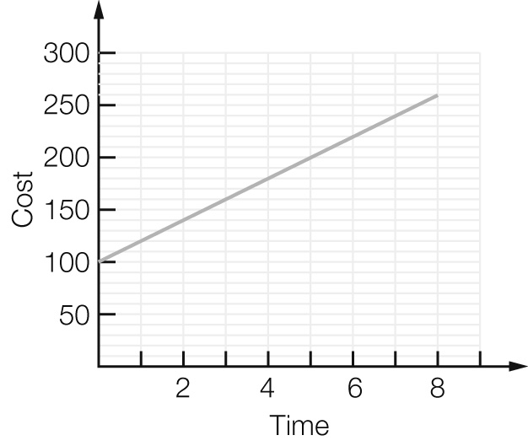

Use the graph to determine what the cost would be if the electrician worked for 3 hours.

A $130 B $150 C $160 D $170

Multiple-choice results: ___ /12

Short answer section

Question 13 4 marks [6.2]

Use words from the list below to complete the following sentences.

*origin slope gradient slope negative left*

*positive y-intercept x-axis Cartesian*

(a) Lines with a _________________ gradient ______________ up to the right and lines with a   
____________ gradient _____________ up to the __________.

(b) The ______________ of a line is a measure of its steepness.

(c) The *x*-intercept is where a line crosses the ___________________ and the ___________________is where a line crosses the *y*-axis.

(d) The point (0, 0) is the _______________ of the _______________ plane.

Question 14 3 marks [6.2]

State whether the following are true or false.

(a) The point (0, -2) lies on the *y*-axis

(b) The point (7, 0) lies on the *y*-axis.

(c) The coordinates of the origin are (0, 0).

Question 15 3 marks [6.1]

Use the graph below to answer the following questions.

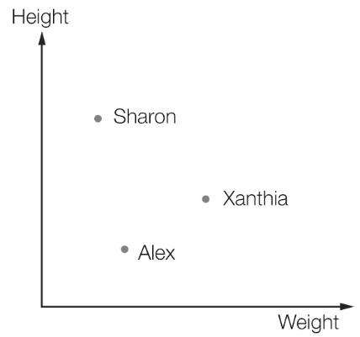

(a) What are the two variables shown in the graph?

(b) Who is the lightest?

(c) Who is the tallest?

Question 16 2 marks [6.1]

The Costa family is travelling by car to their holiday destination. The following graph shows the distance they are from home.

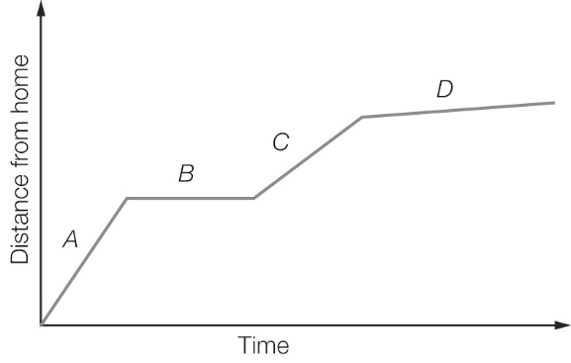

(a) In which section of the graph (*A, B, C* or *D*) are they travelling the fastest?

(b) In which section are they not moving?

Question 17 3 marks [6.2]

Look at the Cartesian plane below and write down the coordinates of the points *A, B* and *C*.

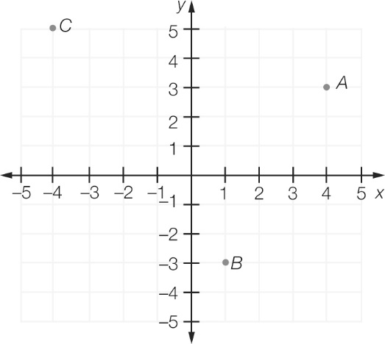

Question 18 2 marks [6.2]

Plot the point (2,-3) on the number plane. Is it in the same position as (-3, 2)? Explain why or why not.

Question 19 6 marks [6.2]

Plot the points from the following table on the number plane. Join the points with a straight line.

|  |  |  |  |  |  |
| --- | --- | --- | --- | --- | --- |
| *x* | -4 | -2 | 0 | 2 | 4 |
| *y* | 8 | 5 | 2 | -1 | -4 |

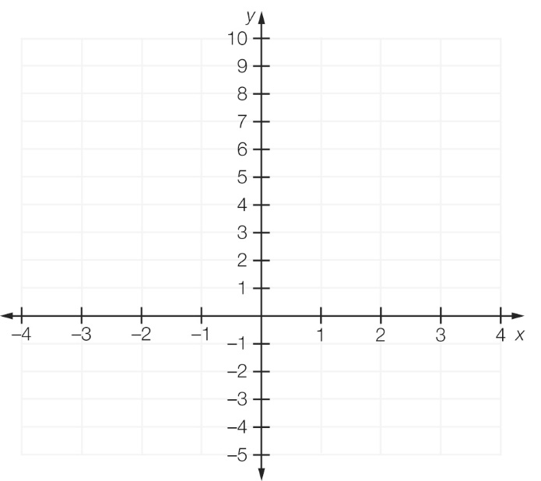

Question 20 4 marks [6.2]

Complete the following ordered pairs given the rule *y* = -5*x* – 10:

(a) (2, ___) (b) (-1, ___) (c) (-2, ___) (d) (3 , ____)

Question 21 1 mark [6.3]

What is the equation of the line that is parallel to the *x*-axis and passes through the point   
(-2, 1)?

Question 22 1 mark [6.3]

What is the equation of the line that is parallel to the *y*-axis and passes through the point   
(4, -2)?

Question 23 4 marks [6.3]

Write the equation of each of the following lines by first finding the gradient and the *y*-intercept.

(a)

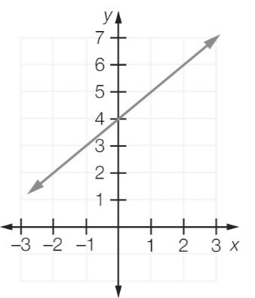

(b)

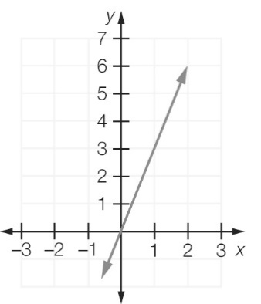

Short answer results: ___ / 33

Extended answer section

Question 24 6 marks [6.1]

A family went for a long drive in a car. At the start of the trip the petrol tank contained 60 L of petrol and was full. After driving 500 km they bought 50 L of petrol to fill the tank. After another 400 km they bought 35 L and this brought the amount of petrol in the tank up to 45 L.

(a) Complete the table of values showing how much petrol was in the tank at different distances on the trip.

|  |  |  |  |  |  |
| --- | --- | --- | --- | --- | --- |
| Distance from start (km) | 0 | 500 | 500 | 900 | 900 |
| Petrol in tank (L) |  |  |  |  |  |

(b) Use your table in (a) to plot a graph of the amount of petrol in the tank.

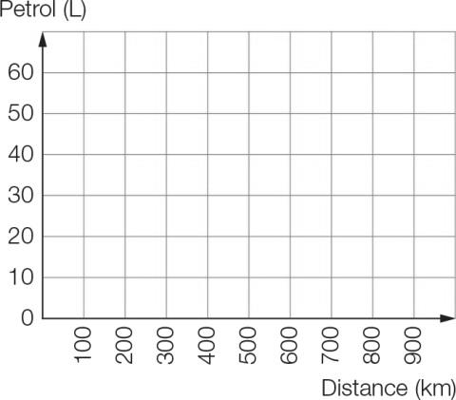

(c) Compare the rate that petrol is being used for the two parts of the trip (in litres per 100 km).

(d) How is the answer to (c) shown on the graph?

Question 25 5 marks [6.3]

The following shapes have been made with matchsticks.

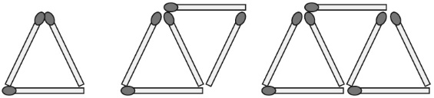

(a) Complete this table of values.

|  |  |
| --- | --- |
| Number of triangles  (*t*) | Number of matches  (*m*) |
| 1 | 3 |
| 2 | 5 |
| 3 |  |
| 4 |  |
| 5 |  |

(b) Find the pattern, or rule, in terms of *m* and *t.*

(c) Plot each pair of values. Join the points with a straight line.

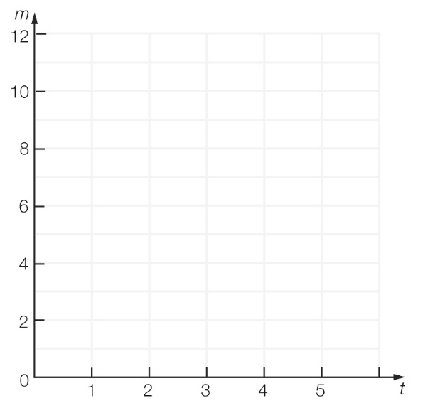

(d) Use the rule you found in (b) to find the number of matches needed for 20 triangles.

Question 26 6 marks [6.3]

(a) A plumber charges a fixed fee of $50 to go to a job plus an extra $20 per hour for the work. Use this information to complete the table of values.

|  |  |  |  |  |  |
| --- | --- | --- | --- | --- | --- |
| Hours worked, *t* | 0 | 1 | 2 | 3 | 4 |
| Cost,  *C* |  |  |  |  |  |

(b) Plot the points from your table of values on the axis below, then join them to form a graph.

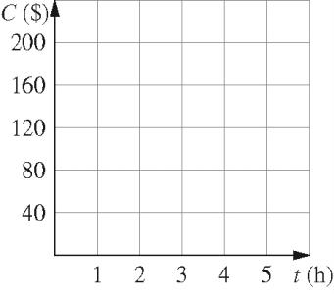

(c) Extend your graph further. How much you will pay if the plumber works for 5 hours?

(d) Write a rule for calculating the cost *C* in terms of time *t* spent.

Question 27 5 marks [6.4]

The toll on the recently completed Radnor bridge is charged as follows:

Each vehicle is charged $1.50 and each occupant in a vehicle is charged $0.20.

(a) What is the toll for a vehicle with one occupant?

(b) What is the rule for the toll *T* in terms of the number of occupants *p*?

(c) What is the toll for a vehicle carrying 20 occupants?

Extended answer results: ___ / 22

TOTAL test results: ___ / 67